COCA COLA – EVENT SCHEDULING
2024 03 13

Attendees:
- Global Technology:
  - Kristen Baum: Sr. Product Manager
    - Product Manager for the UXP project, leading the meeting
  - Luis Bustos: Director, Technology Architect & Strategy
    - Data Architect for the UXP project, explaining the features and integrations
- Coca-Cola Team:
  - Mike Frey: Director Experiential Prod
    - aaa
  - Sarah Davis: SVP Global Coca Cola Lead
    - aa
  - Erin McGivney: SVP Global Coca Cola Lead
    - aaa
  - Brian Baskett: SVP Director Experiential Prod
    - From the XB side, involved in the project.

Next steps
- Kristen and Luis to map out responses related to event scheduling and management for integrating into the UXP system.
- Attendees to provide any additional insights or pain points they think of after the meeting.

Minutes
- Introduction: Kristen and Luis aim to understand how different accounts schedule and recap events, specifically for Coke.
- UXP. Kristen gave a run through the objectives for the UXP.
- Main Discussion: Discussion on current practices of scheduling and managing events, including the use of Google Docs for tracking and recapping. Mention of a unified system to assign IDs to events for better tracking and reporting, referred to as UXP.
- Challenges and Solutions: Discussion of existing processes, identification of pain points (none explicitly mentioned), and discussion on desired features for a new system to improve event management and reporting.
- Conclusion: Acknowledgment of the inputs provided by attendees and indication of further contact as the project progresses.
Notes
Current Process:
How the team feels about current process:
- Mike: Shared detailed insights on current event management practices and expressed satisfaction with the simplicity and straightforwardness of the existing process.
- Sarah and Erin: Participated actively but did not express explicit "positive feedback". They were cooperative in sharing the current state of event scheduling and management.

The team can predict dates for annual events like golf, tennis, and Coachella festivals.
Mike described the following 3 types of events for Coke:
Touring Events
- Initial Planning:
  - Identify target locations and dates for the tour.
  - Determine the product or brand focus for the promotion.
- Scheduling:
  - Use Google Docs to create a comprehensive schedule, shared with both internal and touring teams.
- Logistics Coordination:
  - Arrange transportation and accommodations for the touring team.
  - Organize the setup of promotional materials and event setups at each location.
- Execution:
  - Conduct the events as planned across multiple locations, engaging with the audience through promotional activities.
- Data Collection and Recap:
  - Gather recap data and anecdotal feedback from each location on a separate tab within the Google document.
  - Analyze the data to assess the event's impact and identify areas for improvement.
One-off Events
- Concept Development:
  - Define the purpose and objectives of the event.
  - Design event activities and experiences tailored to the specific occasion.
- Preparation:
  - Schedule the event using Google Docs, ensuring all team members are informed.
  - Coordinate logistics, such as venue booking, materials preparation, and staffing needs.
- Event Launch:
  - Execute the event according to the plan, focusing on engagement and brand promotion.
- Data Collection and Reporting:
  - Collect data on participant engagement, samples distributed, and overall event success.
  - Update the recap section in Google Docs for internal review and client reporting.
2/3 Day Events
- Extended Planning:
  - Plan activities and sessions that span over two to three days, considering the varied interests of attendees.
  - Determine necessary resources, including speakers, materials, and interactive elements.
- Detailed Scheduling:
  - Develop a detailed schedule covering all days of the event, shared via Google Docs with relevant parties.
- Logistics Management:
  - Coordinate detailed logistics, such as accommodation for guests, catering, and venue arrangements.
- Ongoing Execution:
  - Manage the event across its duration, adapting to any real-time changes or challenges.
  - Engage with attendees through multiple touchpoints to maximize the event experience.
- Comprehensive Recap:
  - Collect extensive data on attendee feedback, engagement levels, and logistical success.
  - Update Google Docs with detailed recap information for post-event analysis and improvement strategies.

TOURING EVENT:
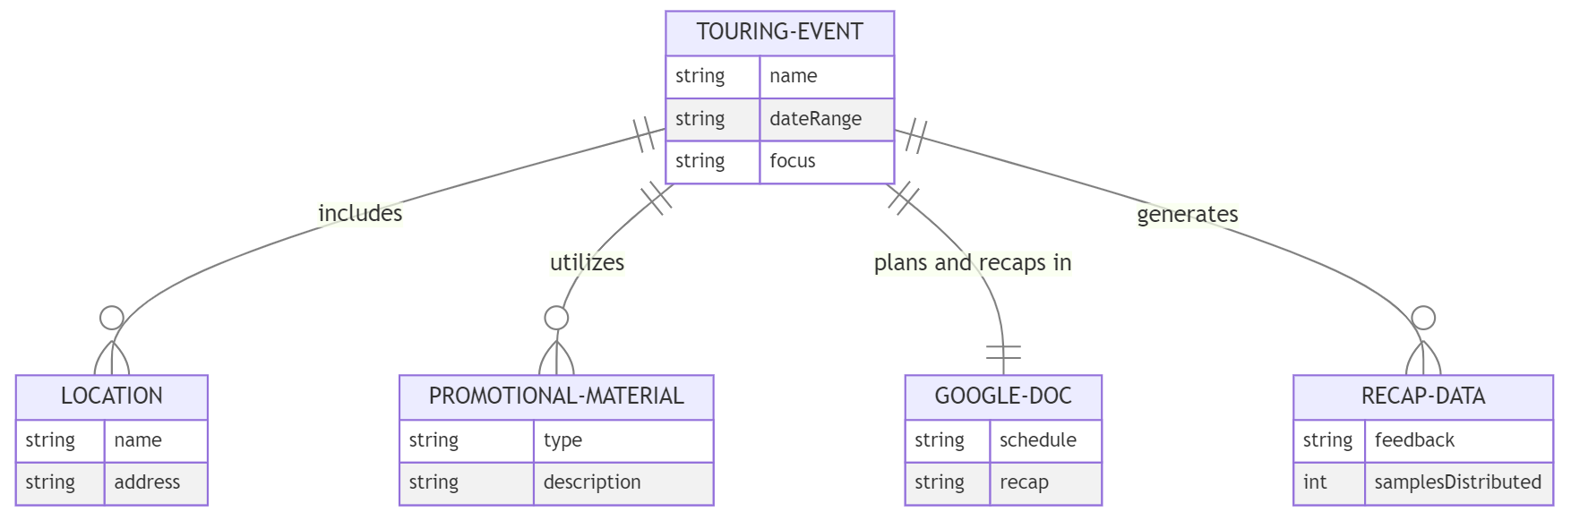
ONE-OFF EVENT:
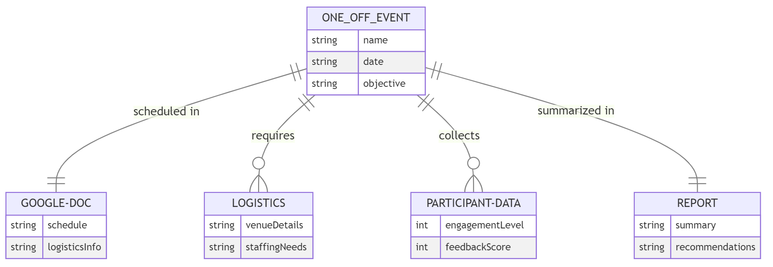
MULTI DAY EVENT: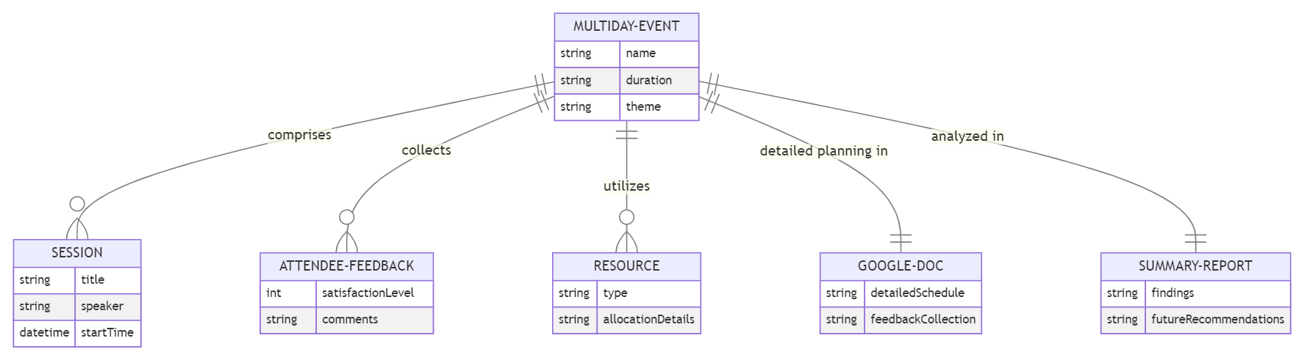

Differences across event types
Aspect | Touring Events | One-off Events | 2/3 Day Events | Commonalities
Duration & Scale | Multi-location, requires travel | Singular, focused within a day | Spans multiple days | -
Objectives & Themes | Broad brand promotion, product sampling | Specific occasions, product launches | Deeper dives into themes, varied sessions | -
Planning Complexity | Dynamic, adapts to each location | Concentrated planning for single setting | Intricate, multiple sessions and activities | Use of Google Docs for planning, scheduling, and recapping
Logistics Coordination | Extensive, across different cities | Detailed for single event setting | Extended logistical arrangements | Careful logistics management, including venue, staffing, and participant engagement
Data Collection & Analysis | Post-event evaluation essential | Crucial for measuring single event impact | Essential for comprehensive feedback | Post-event data collection and analysis for evaluating success and attendee engagement
Reporting | Required for internal and client review | Necessary for concise event insights | Important for detailed event analysis | Creating reports for internal review or client presentation, compiling data and insights
Resource Allocation | Extensive, for travel and venues | Focused on maximizing single event impact | Significant, for accommodations and activities | -
Participant Engagement | Across multiple locations | Focused within the event | Throughout the event duration | Engaging participants and collecting feedback is a core goal across all event types

Coke events, such as number of samples, number of interactions, and number of people that played a game. He also mentioned that the XP team and the BL team work together to input those numbers into a reporting document.

Sara mentioned 2 different mechanisms for managing events and commerce and content on the Coke side.
- 1. A Google doc project tracker and calendar for events, which is color-coded by brand.
- 2. Different mechanism for managing commerce and content, which Sara did not specify.
No issues with people filling data.
- Sarah said that she oversees the events on Coke's side and Aaron oversees the commerce and content.
- She said that they use a Google doc project tracker and calendar for managing events by brand and date.
- She also said that they work closely with the XP team to coordinate the events and that they are mostly based on existing events or promotional windows.
Erin oversees commerce and content on Coke's side.
- Their projects include point of sale material development, toolkit development, in store activation, still photography shoots, and video shoots for shopper programmes.
Staffing agencies. They use staffing agencies for brand ambassadors (BAS) for their events: Assist, Clearly Promotions, and Cast.
They use the data team for reporting metrics to the client, such as samples, interactions, and digital metrics from photo ops and games.
Mike is talking about how the XP team handles the recapping and reporting of events for Coke, such as touring events, one-off events, and interactive elements. He mentions the use of Google docs, staffing agencies, and the data team for these tasks
They collect data such as samples, interactions, and digital metrics from photo ops and games. They use Google docs to track and report these data for touring events and one-off events. They also work with the analytics team and the creative team for larger scale events.
Tracking data: Google docs to track and report samples, interactions, and digital metrics for touring events and one-off events.
PowerPoint or PDF presentations to share weekly reports for touring events with the client. 2
Creative and analytics teams to provide more in-depth metrics and insights for larger scale events. 3
IPCT to collect and report any digital metrics from photo ops and other interactive elements. 4

Sarah is explaining the structure and the process of the events and content team for Coke. She says that they manage their projects and calendar through a Google doc, and that they work closely with the XP team to coordinate the events. She also says that they report metrics to the client using Google Slides, and that they are often asked to show return on investment for the trial-based events.

According to the transcript, they do not do surveys or QR codes for their events. Sarah said that Coke is not interested in that kind of stuff and that they rely on their partners' surveys for some events. 1 Mike also said that they only report basic metrics like samples, interactions, and game plays.

They use the data they receive to create recap reports for the client, which include pictures, metrics, activation overview, schedule, consumer verbatims, and partner survey data. 1 They also use the data to show return on investment, which is a constant request from the client.

